**INSTALL NXLOG SERVICE TO CLIENT COMPUTER**

**Objective:** To deploy Nxlog service to client computers using Windows Server 2012 Group Policy.

**Requirements:**

* Windows Server 2012 Active Directory
* User Account should be member of Local Administrator Group to install the NxLog Software.
* Shared network drive preferrably a Distributed File System (DFS)
* Active Directory Group Policy
* Enable Audit Other Logon/Logoff Events under Computer Configuration Policy
* Enable Screen Saver, Password Protect the Screen Saver, Screen Saver Timeout under User Configuration Policy

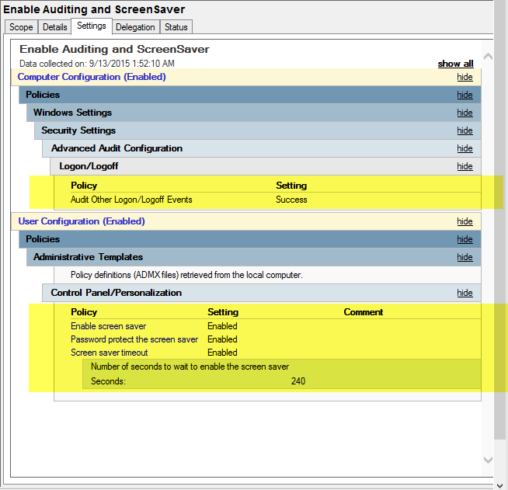

**STEPS TO DEPLOY NXLOG TO CLIENT COMPUTER**

1. Create an OU in Active Directory

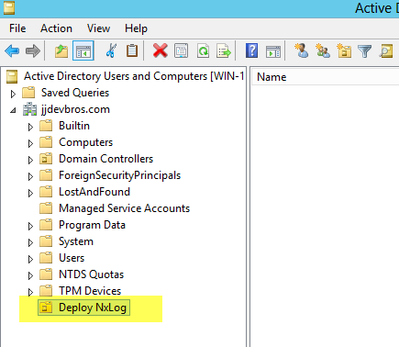

1. Create a Security Group for User and Computer. Add the created groups to the Organizational Unit.

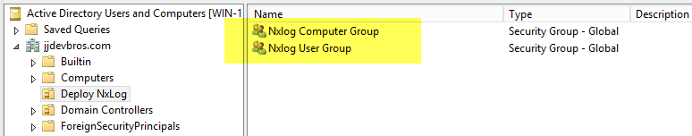

1. Create a Group Policy to install Enable Screen Saver, NxLog software, Password Protect the Screen Saver, Screen Saver Timeout and Edit Nxlog configuration file.

* **ENABLE AUDIT OTHER LOGON/LOGOFF EVENTS AND SCREEN SAVER SETTINGS GROUP POLICY**
  + Create a group policy and name it ENABLE AUDIT OTHER LOGON/LOGOFF EVENTS AND SCREEN SAVER SETTINGS. Link the created Group Policy to the Deploy Nxlog OU.

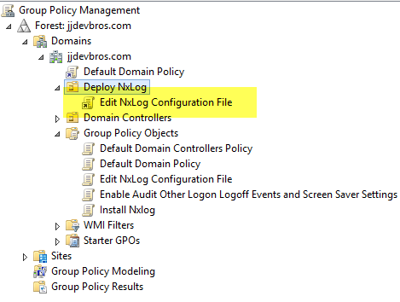

* + To enable the Audit Other Logon/Logoff Events. Go to Computer Configuration - Windows Settings - Security Settings -Advanced Audit Policy Configuration – Logon/Logoff – Audit Other Logon/Logoff Events.

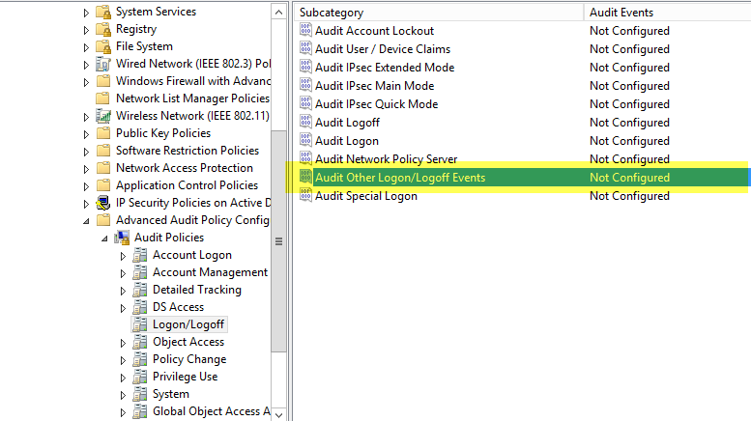

* + Select the Configure the following events and click OK.

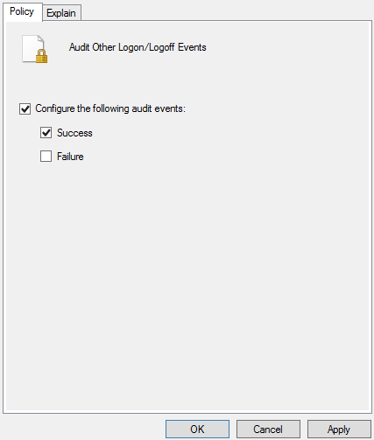

* + To enable SCREEN SAVER SETTINGS go to User Configuration – Policies – Administrative Template – Control Panel – Personalization.
  + Enable the following policies:
    - Enable Screen Saver
    - Password Protect the Screen Saver
    - Screen Saver Timeout

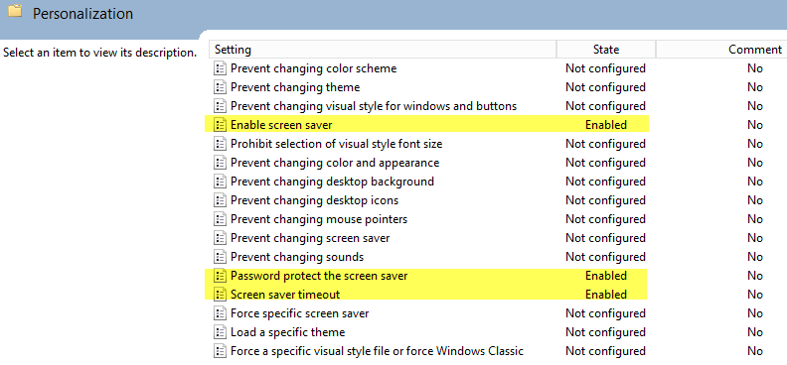

* + Close the Group Policy Management Editor.
* **INSTALL NXLOG GROUP POLICY**
  + Create a group policy and name it INSTALL NXLOG. Link the created Group Policy to the Deploy Nxlog OU.

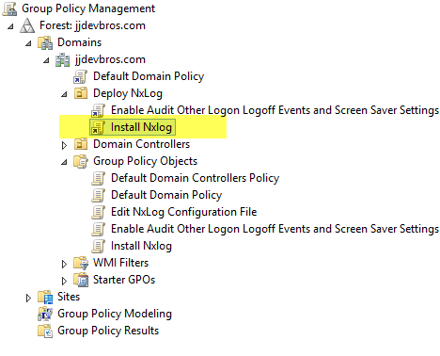

* + Copy the NxLog MSI to the DFS.

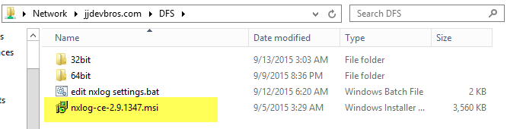

* + Edit the group policy – Computer Configuration – Policy – Software Settings – Software Installation – New Package.

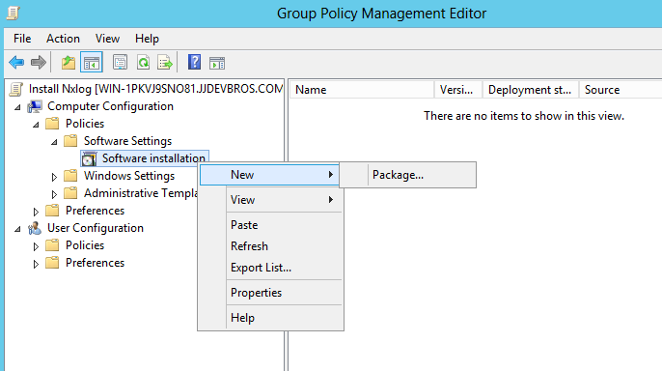

* + Copy the NxLog MSI installer to %SystemRoot%\Sysvol\Domain\Policies. Select the NxLog MSI installer and click Open.

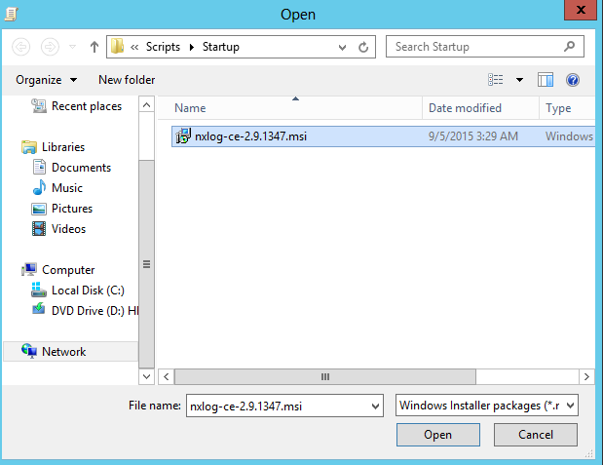

* + Select Assigned Option and Click OK.

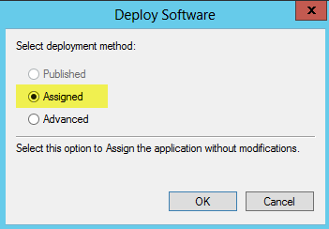

* + Close the Startup Properties and Group Policy Management Editor.
* **DEPLOY NXLOG CONFIGURATION USING BATCH FILE**
  + To deploy the NxLog Configuration Batch File copy the files to the DFS.

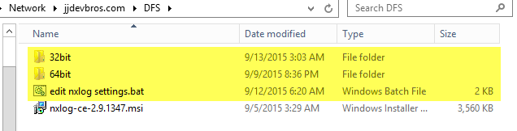

* + Create a group policy and name it Edit NxLog Configuration File. Link the created Group Policy to the Deploy NxLog OU.

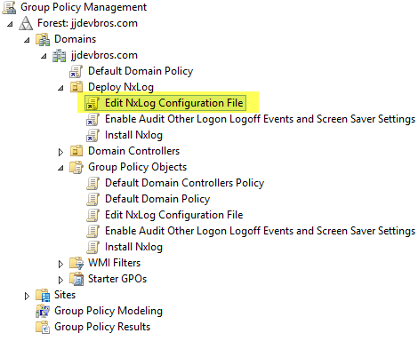

* + Copy the Edit Nxlog Settings Batch file to %Systemroot%\Sysvol\ Domain\Policies.

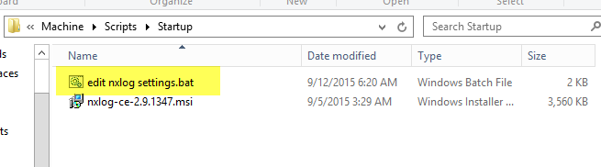

* + Add the Edit Nxlog Settings.bat to Computer Configuration – Policy – Windows Settings – Script (Startup/Shutdown).

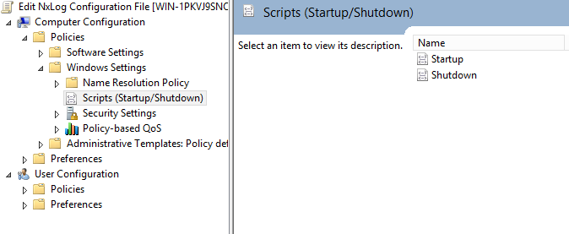

* + Edit the Startup Script to add the Edit Nxlog Settings.bat.

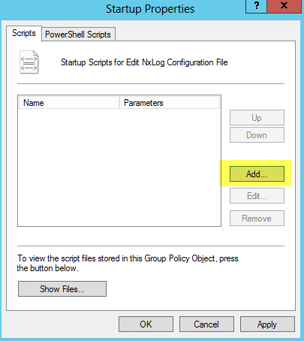

* + Click on Browse Button to locate the Edit Nxlog Settings.bat.

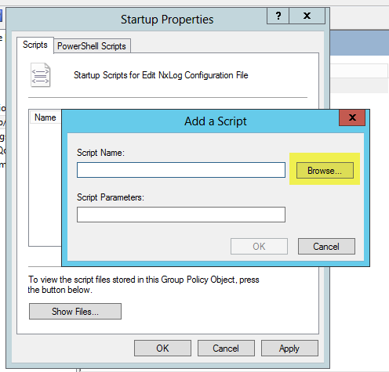

* + Select the Edit Nxlog Settings bat and click Open Button.

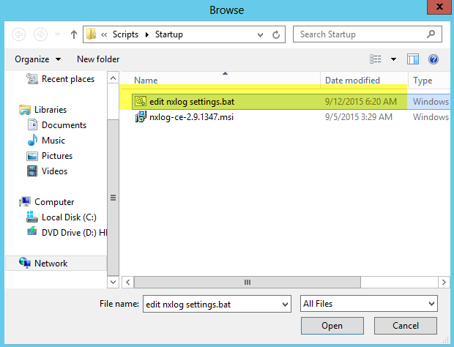

* + Close the Startup Script Properties and the Group Policy Management Editor.